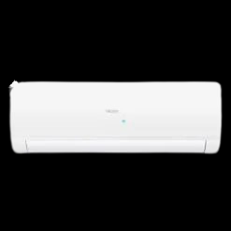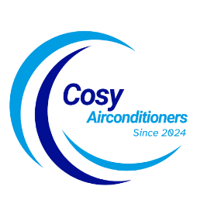

SKU: HSU-12HFTCD/WSDC(S)-T3

**Thunder Inverter**

Rs 145,999.00 Rs 122,999.00

T3 Ultra Big Outdoor

Upto 52°C Full BTU

Self Cleaning

With adoption of optimized cooling system, the cooling capacity of Haier Air Conditioners still could catch up 100% to provide the best cooling experience to user at 46◦C high temperature

**THANK YOU!**

**Product details**

**WELLCOME TO OUR WEBSITE**